**ArcCASPER User Manual**

A Network Analyst Evacuation Routing Extension



**Kaveh Shahabi**

**Spatial Sciences Institute**

**Computer Science Department**

**University of Southern California**

# Introduction

This how-to document covers what the end user needs to know about “Evacuation Routing Analysis”. It’s recommended that the user gets familiar with other built-in Network Analyst tools beforehand. Repetitive instructions that are common among other analysis like ‘Route’ and ‘Closest Facility’ will not be highlighted here. Following is a good online tutorial in this regard.

<http://help.arcgis.com/en/arcgisdesktop/10.0/help/index.html#//00470000005r000000.htm>

# Installation

Download: <http://www.esri.com/arccasper>

Nightly Builds: <https://www.dropbox.com/sh/b01zkyb6ka56xiv/oOjJBINPIr>

Technical Article: <http://www.sciencedirect.com/science/article/pii/S0198971514000428>

Support: <http://www.facebook.com/arccasper>

In order to install, first unzip the downloaded file. Next, install both versions of the [Visual C++ Redistributable packages](http://www.microsoft.com/en-us/download/details.aspx?id=40784). Then execute the "install.cmd" script. This script needs to run as administrator in Windows Visa and later operating systems. Make sure any previous ArcCASPER installation is completely uninstalled. After installation, you should not move the content of the folder specially the DLL files. The script is going to install both 32bit and 64bit editions. You will need ArcGIS [64bit background geo-processing patch](http://resources.arcgis.com/en/help/main/10.1/index.html#//002100000040000000) in order to take advantage of the 64bit evacuation routing and simulation.

To uninstall the tool, simply execute the “uninstall.cmd” script and then remove the folder. Don’t forget to backup your data.

### Requirements:

* [Visual C++ Redistributable Packages for Visual Studio 2013](http://www.microsoft.com/en-us/download/details.aspx?id=40784) (Install both x86 and x64 versions)
* ArcGIS Desktop 10.2
* Network Analyst Extension
* (Optional) Background Geoprocessing (64-bit)

**Caution:** After upgrading your tool, your analysis layer may become unsolvable due to incompatibilities. To avoid this, always export the evacuation data (evacuees, routes, etc.) before attempting to solve.

# Section 1: Build a Network Dataset

Figure : Network Dataset Properties

In order to create and build a network dataset from your street data files please follow the link below:

<http://help.arcgis.com/en/arcgisdesktop/10.0/help/index.html#/Exercise_1_Creating_a_network_dataset/00470000005t000000/>

Once your network dataset is ready, you need to create one additional network attribute called “Capacity”.

### Steps:

1. Start ArcMap by clicking Start > All Programs > ArcGIS > ArcMap.
2. Enable the Network Analyst extension if you haven’t done so already.
   1. Click Customize > Extensions.
   2. The Extensions dialog box opens.
   3. Check Network Analyst.
   4. Click Close.
3. Open the Catalog window. Click Window > Catalog.
4. Locate your network dataset, then right click on it and select “Properties” (Figure 1)
5. Navigate to the “Attributes” tab. Here you’ll see previously identified attributes.
6. Adding “Capacity” attribute:
   1. Click “Add”
   2. Choose the name “Capacity”
   3. Usage type “Descriptor”
   4. Data Type “Double” or “Integer”. It depends on the related street shapefile field type.
   5. Click OK when you’re done.
7. Click “Apply”
8. Now select “Capacity” from the list and click “Evaluators”.

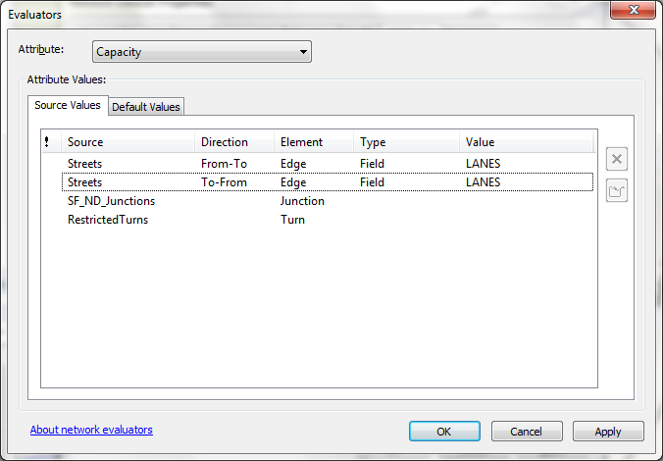

Figure : Capacity Network Attribute Evaluator

1. Now you have to specify which field of your street shapefile indicates road width or capacity. For example number of lanes could be one possibility. Set this only for the edges and leave the junction empty (Figure 2). If you do not see your desired field, go back to step ‎6.d and change the data type. When you’re done click “OK”.
2. Click OK to exit network properties.
3. Build the network dataset.

# Section 2: Identify Zones

In order to perform an evacuation routing, you need two sets of points: Safe Zone Points, and Evacuee Points. Safe zones are simply locations on the map where evacuees need to be routed to. Each safe zone has a capacity which limits the number of evacuees routed to each safe zone. If you want to have some safe zones with unlimited capacity, set their capacity to -1.

Evacuee points are locations of people who are in danger. Each evacuee point needs to have a name field and a population field. The population indicates the number of people at that location that need to be evacuated. The tool assumes each person at an evacuee location will take a separate car, so if you want multiple people to evacuate per car, which could reduce road congestion, you will need to divide this out in your data.

Let us have an example. Imagine a tsunami is coming toward San Francisco and we need to evacuate people who live close to the west side toward inland (Figure 5). We can use the Census block group population data for evacuees. A safe zone is simply a location with a good distance from the shoreline.

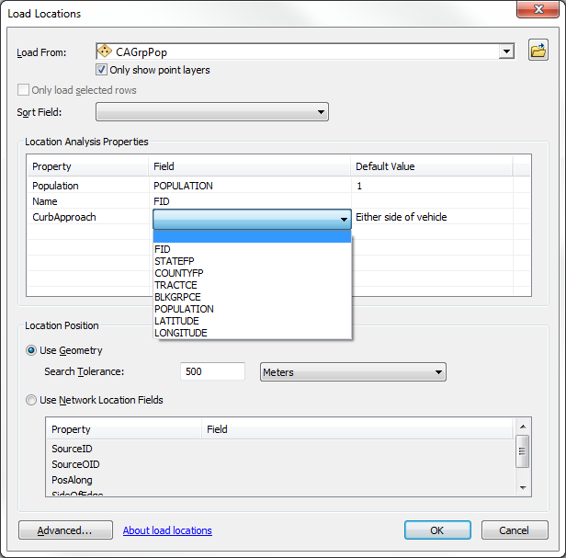

Figure : “Load Locations” window for Evacuees.

In this example we import California block group points as evacuees.

### Steps:

1. Locate the Network Analyst toolbar in ArcMap. Click on “Network Analyst Window” so that you can see newly added layers.
2. From the toolbar, open the Network Analyst drop menu and select “New Evacuation Routing”. This will create a new empty layer and six sub-layers which you can see in the Network Analyst Window.
3. Right-click on “Zones” layer from Network Analyst Window and select “load locations”. Select the point shapefile with safe zone points.
4. Right-click on “Evacuees” layer from Network Analyst Window and select “load locations”. Select the point shapefile with population data. Select the appropriate fields for population and name (Figure 3).

Now you’re ready to perform the evacuation routing.

# Section 3: Evacuation Setting

If you right-click on the “Evacuation Routing” layer from the table of contents and select “Properties”, you will see the evacuation options (Figure 4). Below are short descriptions of the evacuation options:

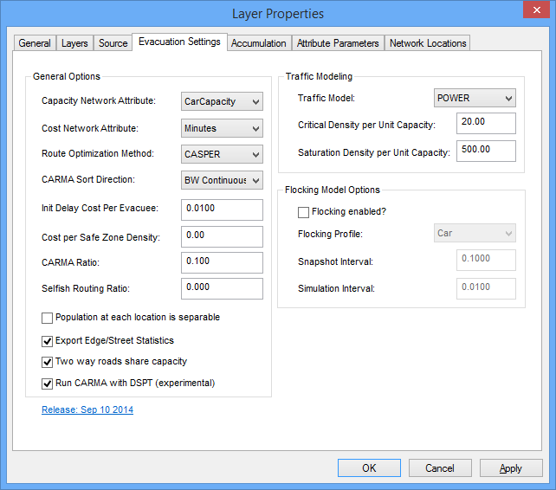

Figure : Evacuation Options Window

* **Cost (Impedance) Network Attribute:** Select your impedance or cost attribute. Preferably pick something in “minutes”. Some of the settings’ default values are based on “minutes” as the unit of time.
* **Capacity Network Attribute:** Indicates the “Capacity” network attribute that we added in Section 1. Make sure it’s set correctly. The program will read roads widths/lanes/capacities through this attribute.
* **Route Optimization Method:** Indicates the routing algorithm. The interested reader can read the [technical article](http://www.sciencedirect.com/science/article/pii/S0198971514000428) which explains the mathematical details of these algorithms.
  + **SP:** ShortestPath search for each evacuee. All the capacities will be ignored. This will technically make the program behave like the Closet Facility tool.
  + **CCRP:** A known capacity constrained technique which will fill up each path with evacuees from source to sink ([more](http://link.springer.com/chapter/10.1007%2F11535331_17)).
  + **CASPER:** Capacity-Aware ShortestPath Evacuation Routing which will use the traffic model to determine realistic traversal speeds for each road segment based on road capacity and number of evacuees (population).
* **Init Delay Cost Per Evacuee:** This number indicates the initial space between evacuees that are sharing their start locations. This translates to evacuee density on each road segment. For example, if you used *Minutes* for your *Cost Network Attribute* and set this parameter to one, each evacuee would leave their location in one minute intervals. This can reduce congestion and therefore overall evacuation time, but depending on the size of the population at a certain threshold it could add significant time to the overall evacuation.
* **Cost per Safe Zone Density:** If safe zones have a limited capacity, this parameter helps the program prioritize safe zones. For example if a nearby safe zone is already full with 100 evacuees how far should one evacuee be routed for the next safe zone? If the network impedance is in *minutes* and *Cost per Safe Zone Density* is 10, the evacuee is willing to travel an extra 0.1 minutes to find another safe zone. In general, a *cost per density* value of *zero* means we do not want to enforce safe zone capacity. Higher *cost per density* values means we prefer to have a more balanced population density over the safe zones. With higher values, the total evacuation time may increase.
* **CARMA Ratio:** CARMA (Capacity Aware Reverse Map Analyzer) is a helper algorithm within CASPER which updates graph vertices based on some heuristic. The heuristic can guide the path finding during CASPER run. By keeping these vertices up-to-date, CASPER will run faster and might be able to find better routes as well. CARMA ratio should be a number from 0.0 to 1.0. Setting the ratio to 0.0 means vertices will be always up-to-date. Setting it to 1.0 means vertices will be updated only once at the beginning. It’s recommended to leave this value at its default.
* **Population at each location is separable:** This checkbox indicates if the program is allowed to separate the population at each location in order to optimize the routes. This will possibly take more time to compute but might lower the total evacuation time. This option may affect how safe zone density is processed.
* **Export Edge/Street Statistics:** If you select this, the tool will also output the edge reservations, which will be helpful in understanding the network bottlenecks.
* **Two-way roads share capacity:** Will tell the program that the capacity of two-way road segments is shared between both directions as opposed to each direction having that much capacity. This is usually the case with road segments without a divider. However if you want to allow contraflow (allowing every lane to travel in the direction toward safety), this option would be no help. You have to directly modify your network dataset. For example you have to select some of your street segments and change their number of lanes. Re-build the network dataset afterwards.
* **Run CARMA with DSPT:** This enables a newer version of CARMA where heuristic values are updated using dynamic shortest path tree (DSPT) algorithm. This version of CARMA is experimental.
* **Traffic Model:** User can select different traffic modeling methods. These models help the program predict traffic delays on saturated road segments. Only CASPER optimization method can benefit from these models.
* **Critical Density per Unit Capacity:** This constant indicates the critical density of a road with one unit of capacity (e.g. one lane). It means the road can route up to this many evacuees without affecting the traversal speed. Here density refers to the number of evacuees (cars) per a unit of cost (impedance).
* **Saturation Density per Unit Capacity:** This constant indicates the saturation density of a road with one unit of capacity (e.g. one lane). It means if the road is routing this many evacuees, its traversal speed will reduce to half of the original traversal speed.
* **Flocking model:** This version of ArcCASPER is equipped with a simulation model. The simulation is based on the work by [Craig Reynolds](http://www.red3d.com/cwr/boids/). If you enable this model, after the routing is done, the program will simulate each evacuee (car) second by second on the road network from source to destination. This enables you to compare final results, animate the evacuation scenario, verify the correctness of the traffic model, observe traffic congestions, and more. The simulation process is extremely slow and should not be attempted in large geographical areas.
* **Flocking Profile:** Indicates the type of evacuee’s vehicle. This will directly affects the physics of the simulation like top speed, dimension, acceleration, safe distance from other vehicles, etc.
* **Simulation Interval:** Indicates the temporal resolution of the simulation. For example a value of 0.01 (assuming *minutes* for impedance value) means simulation will compute evacuee location every 0.6 seconds.
* **Snapshot Interval:** Indicates how often the simulation should store the evacuee locations. This will directly affect the length of the final animation. For example a value of 0.1 (assuming *minutes* for impedance value) means the simulation points are stored every 6 seconds. So the final animation will have a frame every 6 seconds.

# Section 4: Output

In order to get the evacuation routes, from the toolbar, click on “Solve”. Once it’s finished, three output tables will be populated with results which we briefly explain in this section. Please note that ArcMap stores all these layers in the map document (.mxd file) and not in your default geodatabase. It’s good practice to always export output layers to your main data location after every “Solve”.

## Routes

Routes are polylines from each evacuee to the selected safe zone. If the ‘Separable Evacuee’ was ON, there would be many routes for each evacuee location. Figure 5 shows routes for our San Francisco tsunami scenario. Each route has the following attributes.

* **EvcCost**: Indicates total traversal cost on the route considering the congestions.
* **OrgCost**: Indicates the traversal cost without congestion considerations.
* **Pop:** Shows how many evacuees will be on this route.
* **Name:** Name of the evacuee from the ‘Evacuees’ table. It can be used to join results with the origin points.
* **ObjectID:** This is an auto-generated unique number for each route. If you want to know in which order the algorithm assigned routes to evacuees, you can sort the ‘Routes’ table by ‘ObjectID’. In another words, the ‘ObjectID’s are being generated as the routes being reserved on the network.

## EdgeStats

This table lists all touched street segments with useful information about them. By visualizing this table the user can learn about the shortcomings of the network dataset in terms of capacity bottlenecks and safe zone availability. This table is populated only if the ‘Export Edge Statistics’ option is ON. Below you will find information about each ‘EdgeStats’ attribute.

* **EdgeID, Direction, SourceID, SourceOID:** The four of them uniquely identify one edge in the network dataset. The polyline shape however comes from the original ‘streets’ shapefile.
* **ReservPop:** Number of evacuees that are set to pass this edge during evacuation not necessarily at the same time.
* **TravCost:** the traversal cost for this edge with congestion consideration.
* **OrgCost:** The original traversal cost of this edge according to the network dataset.
* **Congestion:** A number from 1 to 10,000 which indicates the congestion ratio on this edge. Equals ‘TravCost’ divided by ‘OrgCost’.

## Flocks

This table will be created if the simulation option is ON. It will have a point for every single evacuee at every time step. Each point has the following attribute:

* **Name:** Name of the evacuee point that this single evacuee belongs too.
* **ID:** Unique ID for every single evacuee.
* **Cost:** The traveled cost that this single evacuee had so far
* **Velocity:** traversal speed as a vector in minutes per meter (assuming *minutes* for impedance value).
* **Speed:** Scalar current speed
* **Traveled:** distanced traveled in meters
* **MyTime:** Accurate time in current format. Can be used to create time-enabled layer.
* **PassedMin:** Exact minutes passed the start of the simulation as a floating-point number
* **Status:** The status of a single evacuee can be Moving, Stopped, Collided, and End.

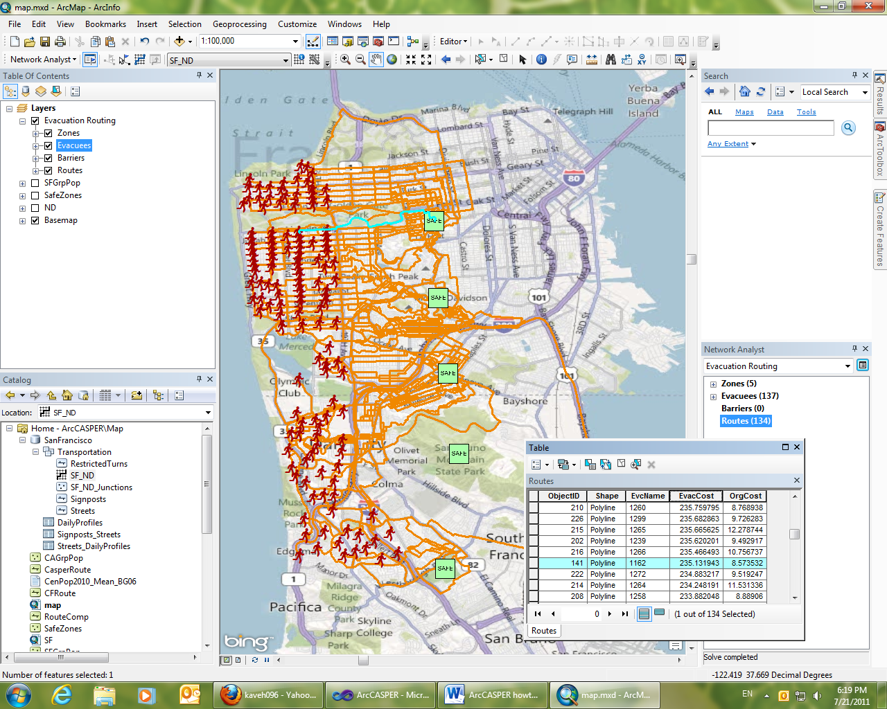

Figure : Calculated Evacuation Routes for Bay Area

# Known Issues

* Multi-part turn restriction: The routing algorithm does not take into account complex (multi-part) turn restrictions that your network dataset may have. There are no workarounds at the moment.
* Sort by ‘name’ in route table: Sorting the ‘Routes’ table by name (which is same as evacuee name) does not work. Also joining this table may result in unexpected behavior. The workaround is to export the routes as a separate shapefile and continue from there.

# Acknowledgement

We would like to thank ESRI APL and Network Analyst teams to support us during the development of this tool.

# Copyright

ArcCASPER tool is released as free closed-source software.

If you decided to use our tool in your work, we would ask that you cite it as:

K. Shahabi and J. P. Wilson, “CASPER: Intelligent capacity-aware evacuation routing,” Computers, Environment and Urban Systems, vol. 46, pp. 12–24, Apr. 2014

# Disclaimer

NO WARRANTIES. The SOFTWARE PRODUCT and any related documentation is provided “as is” without warranty of any kind, either expressed or implied, including, without limitation, the implied warranties or merchantability, fitness for a particular purpose, or non-infringement. The entire risk arising out of use or performance of the SOFTWARE PRODUCT remains with you.